Top Trumps

在這個專案中，我們要訓練電腦玩卡牌遊戲

In this project you will train a computer to play a card game.

遊戲獲勝條件：卡片上的某些欄位數字，你需要擁有最大的數字才能獲勝，如果是其他欄位，則你的數字要最小。數字的大小範圍會變動

For some values on the cards, you win by having the highest number. For others, you win by having the lowest. The range of numbers for different values will vary.

這個專案的目標是讓電腦在沒有指引下學會怎麼玩這遊戲（不能告訴電腦所有的卡牌列表，也不能告訴電腦遊戲規則）

The aim will be for the computer to learn how to play the game well without you having to give it a list of all the cards or tell it the rules.

你將會給電腦一些遊戲過程範例，並實作兩種不同的方式來訓練電腦玩這個遊戲。

Instead, you’ll try two different ways of training the computer to play the game by giving it examples of the game being played.

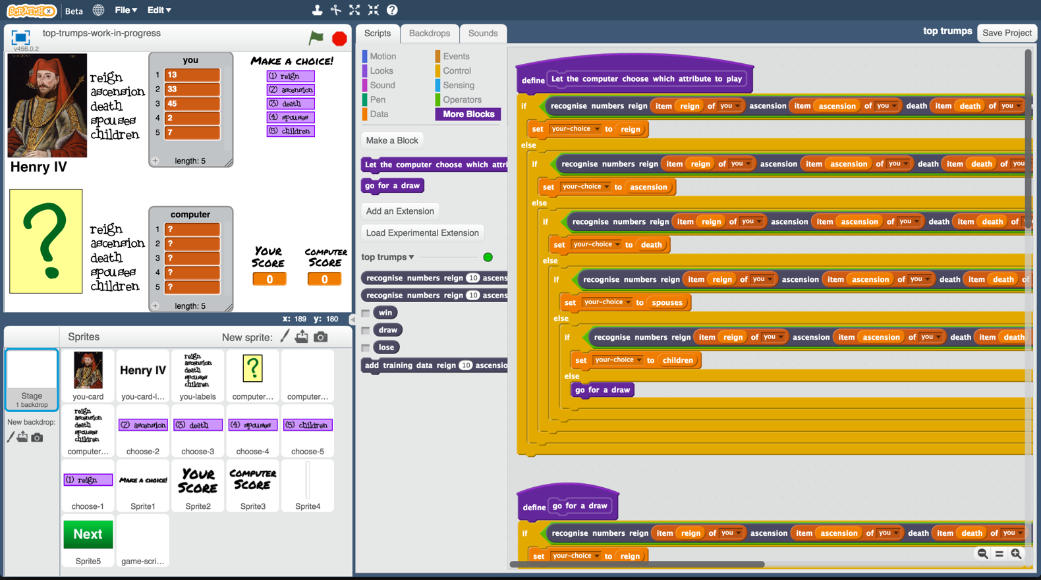

This project worksheet is licensed under a Creative Commons Attribution Non-Commercial Share-Alike License

http://creativecommons.org/licenses/by-nc-sa/4.0/

**你需要做什麼？**

**What will you be doing?**

你要訓練一個機器學習模型，讓他可以自己玩Top Trumps這個遊戲

You’ll be training a machine learning model to play a Top Trumps game based on Kings and Queens of England.

遊戲裡每張卡牌都是一個國王(King)或王后(Queen)

Each card is based on a different King or Queen.

每張卡牌上面都會有五個數字：

統治時間(Reign)：國王/王后在位多長時間

即位時間(Ascension)：國王/王后幾歲登基

死亡時間(Death)：國王/王后幾歲死亡

配偶(Spouses)：國王/王后有幾名配偶

子嗣(Children)：國王/王后有幾名小孩

Each card has five numbers on it:

Reign – how long they were king or queen for

Ascension – how old they were when they became king or queen

Death – how old they were when they died

Spouses – how many husbands or wives they had

Children – how many children they had

範例：

For example:   
 

查理一世(Charles I )

1. 他在位**23** 年

如果我選擇這個欄位，當查理一世在位時間比我對手卡牌的在位時間長，那麼我就獲勝

2) 他 **24**歲時登基

如果我選擇這個欄位，當查理一世登基年紀比我對手卡牌的登基年紀小，那麼我就獲勝

3) 他**48**歲時死亡

如果我選擇這個欄位，當查理一世活得比我對手卡牌久，那麼我就獲勝

4) 他有**1** 名配偶

如果我選擇這個欄位，當查理一世配偶數量比我對手卡牌的配偶數量多，那麼我就獲勝

5) 他有 **9** 個小孩

如果我選擇這個欄位，當查理一世小孩數量比我對手卡牌的小孩數量多，那麼我就獲勝

Charles I

1) He reigned for **23** years  
 If I choose this, and he was King longer than my opponent’s card, I’ll win

2) He ascended to the throne when he was **24**

If I choose this, and he became King earlier than my opponent’s card, I’ll win

3) He died when he was **48**

If I choose this, and he lived longer than my opponent’s card, I’ll win

4) He had **1** spouse

If I choose this, and he had more spouses than my opponent’s card, I’ll win

5) He had **9** children

If I choose this, and he had more children than my opponent’s card, I’ll win.

1. 搜尋網頁：<https://machinelearningforkids.co.uk/>

Go to <https://machinelearningforkids.co.uk/> in a web browser

1. 點選“**Get started**”按鈕

Click on “**Get started**”

1. 點選“**Log In**”按鈕並登入系統

*如果你沒有帳號，請你的老師幫你建立一個帳號。*

*如果你不記得你的帳號或密碼，請你的老師幫你重新設定一次。*

Click on “**Log In**” and type in your username and password  
*If you don’t have a username, ask your teacher or group leader to create one for you.  
If you can’t remember your username or password, ask your teacher or group leader to reset it for you.*

1. 點選上方清單中的 **”Projects”** 按鈕

Click on “**Projects**” on the top menu bar

1. 點選 “**+ Add a new project**” 按鈕

Click the **“+ Add a new project**” button.

1. 將你的專案命名為 “top trumps”並設定成辨識 “**numbers**”類別

Name your project “top trumps” and set it to learn how to recognise “**numbers**”  
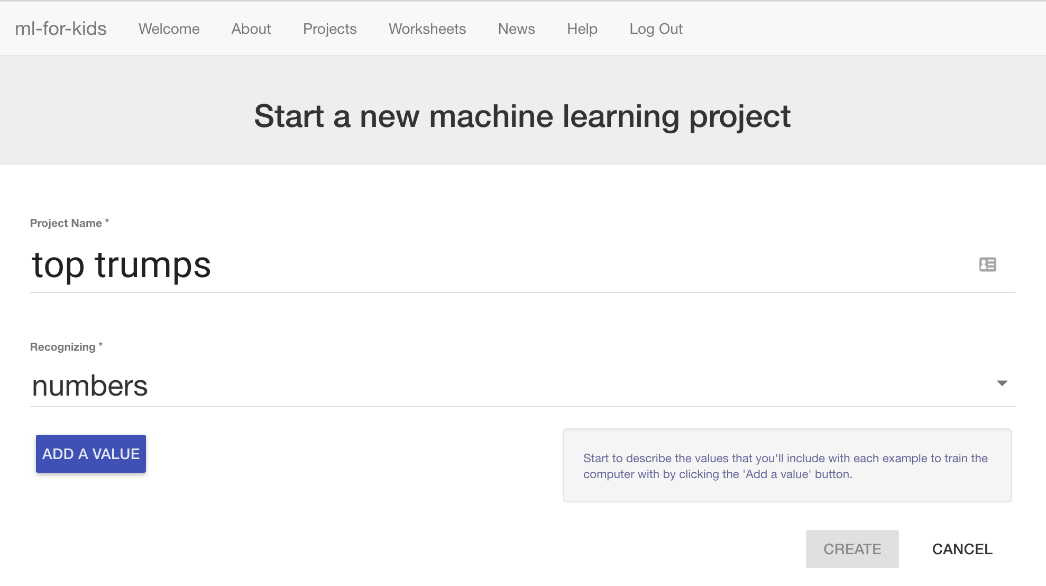

1. 點選“**Add a value**”按鈕五次，在輸入格中依序輸入下列文字，類別都選擇”number”：

* reign  
 * ascension  
 * death   
 * spouses  
 * children

這些方框會被用來儲存卡牌上的資訊

Click the “**Add a value**” button five times.   
That will give you five text boxes to type names into.   
  
Enter the following names into these boxes, in this order:  
 * reign  
 * ascension  
 * death   
 * spouses  
 * children  
  
Set the type for all of these to “number”  
  
*These will be where you put the numbers that are on a Top Trumps card.*  
  
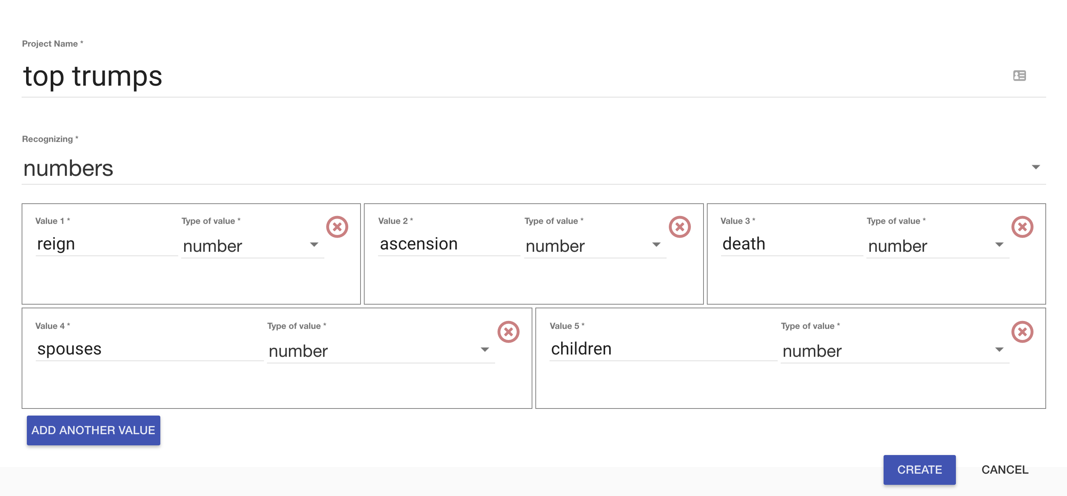

1. 點選“**Create**”按鈕

Click the “**Create**” button

1. 你會在專案清單中看到“**top trumps**”，點選此專案

You should now see “**top trumps**” in the projects list. Click on it.  
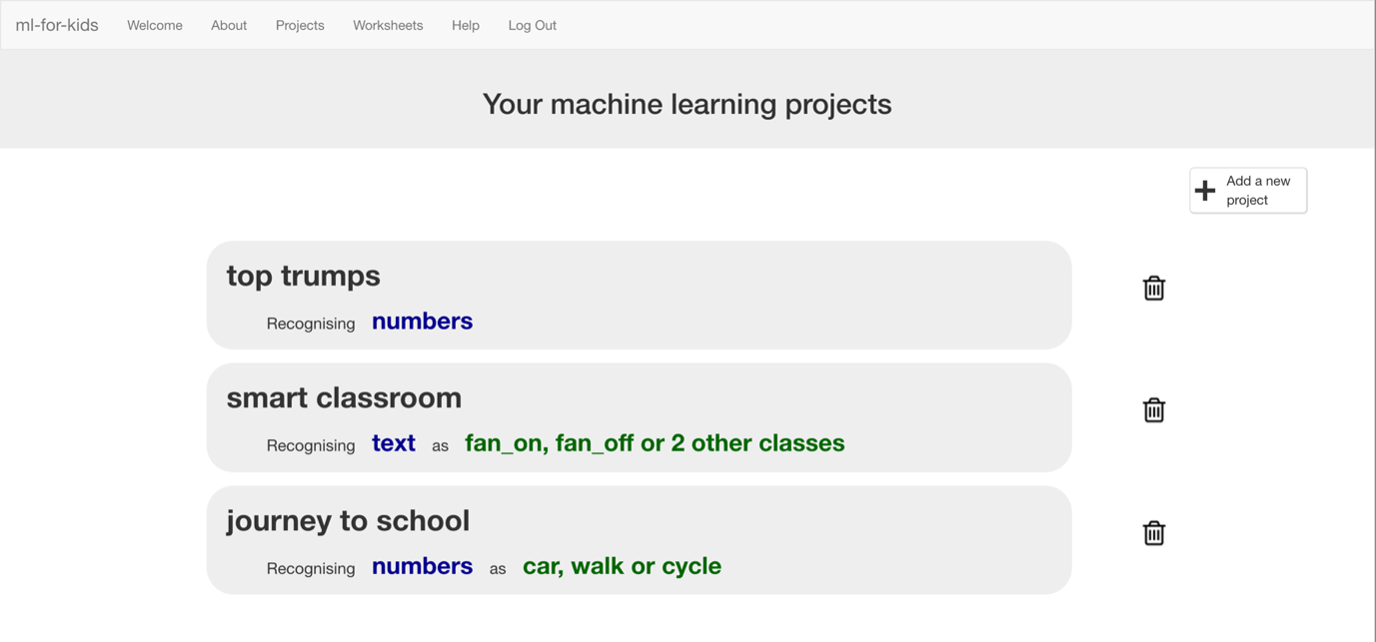

1. 點選 “**+ Add new label**”按鈕，新增名為”reign”的方框

Click the “**+ Add new label**” button, and create a label called “reign”  
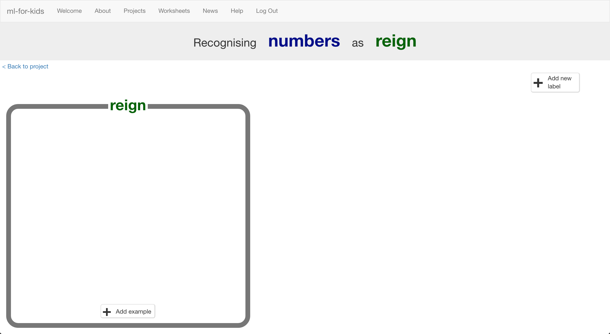

1. 重複上個步驟，新增ascension、death、spouses和children四個方框

*這些是每輪遊戲裡可以選擇的選項*

Use the “**+ Add new label**” button four more times to create labels for “ascension”, “death”, “spouses”, and “children”  
*These are the choices available in each turn of the Top Trumps game.*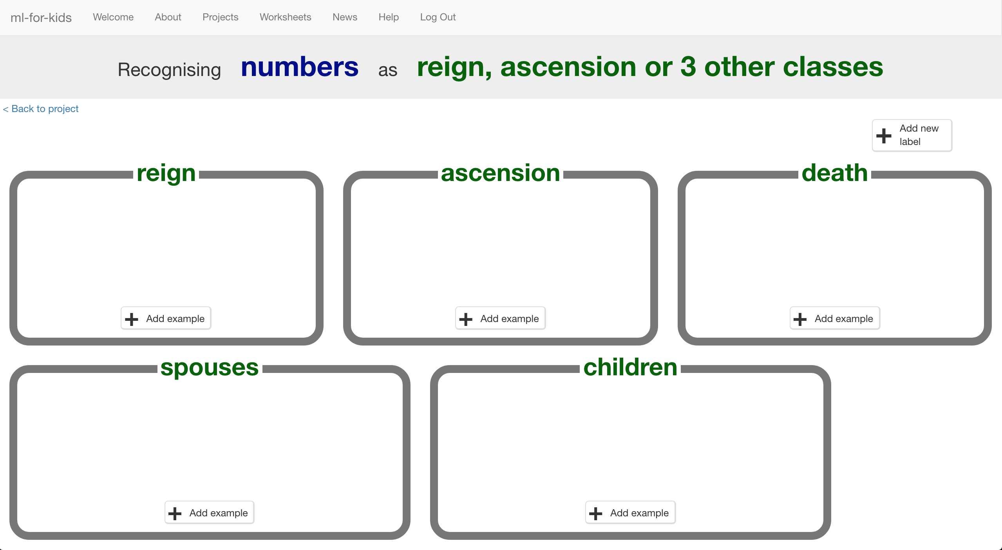

1. 點選“**< Back to project**”

Click the **“< Back to project**” link

1. 點選**Scratch**按鈕

Start by getting a project ready in Scratch. Click the **Scratch** button.  
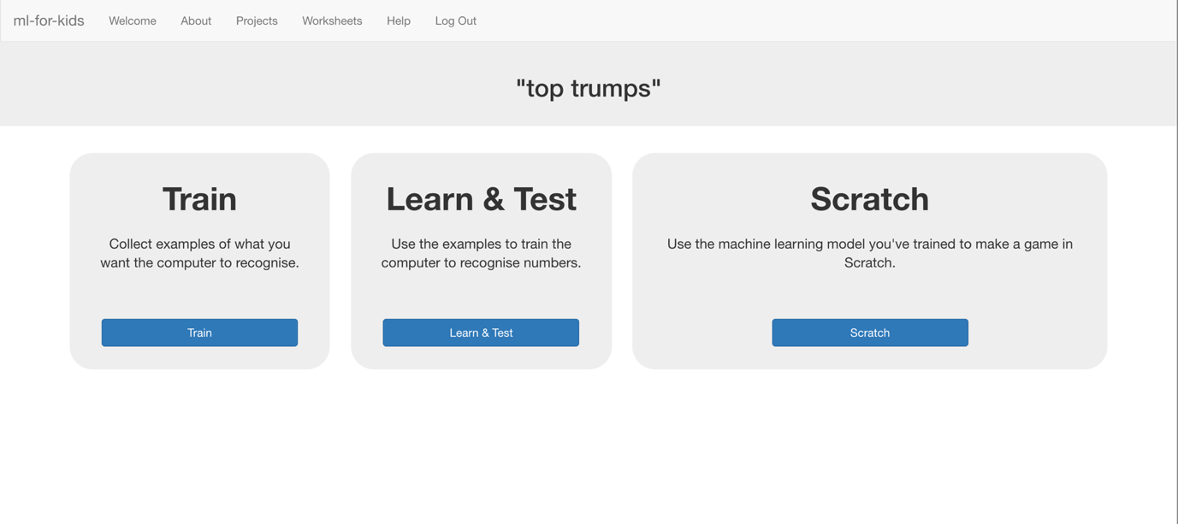

1. 點選**Straight into Scratch**按鈕

*這時會出現一個警告，提醒你還沒有訓練電腦，但這沒關係，因為我們要用Scratch來搜集訓練用的範例。*

Click the “**Open in Scratch**” button  
*It will warn you that you haven’t trained a machine learning model yet, but that’s okay as you’ll be using Scratch to collect training data, so click the “****straight into Scratch****” button.*   
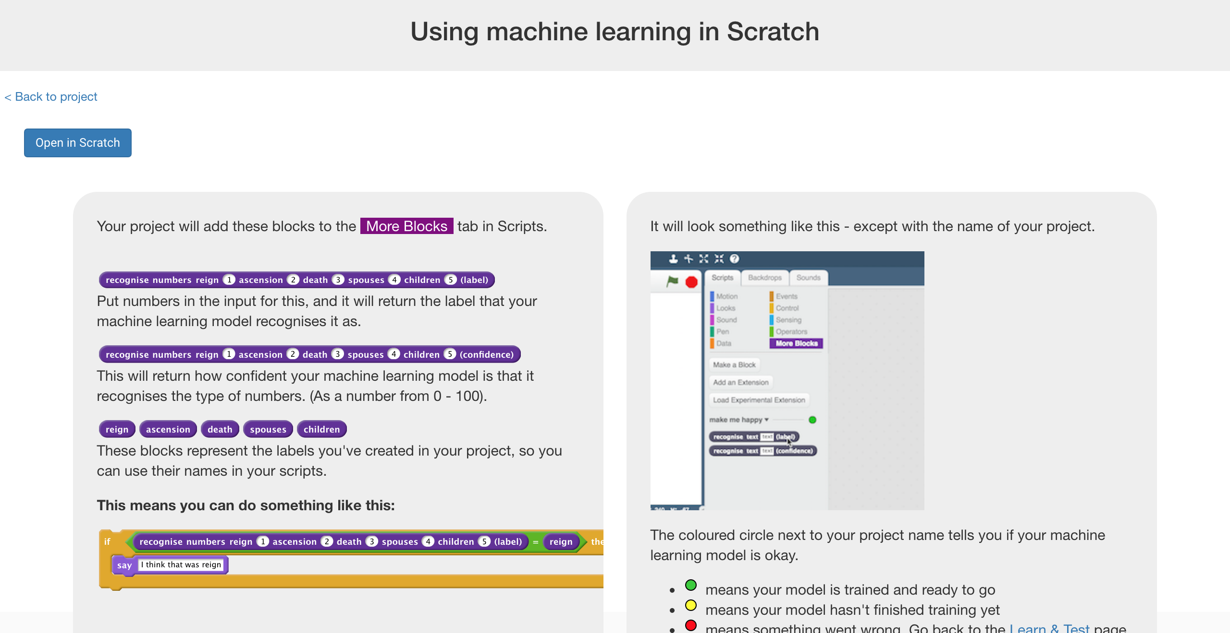

1. 開啟Top Trumps專案

*點選****Project templates，****再點選****Top Trumps***

Load the Top Trumps project template   
*Use* ***Project templates -> Top Trumps*** *as shown below  
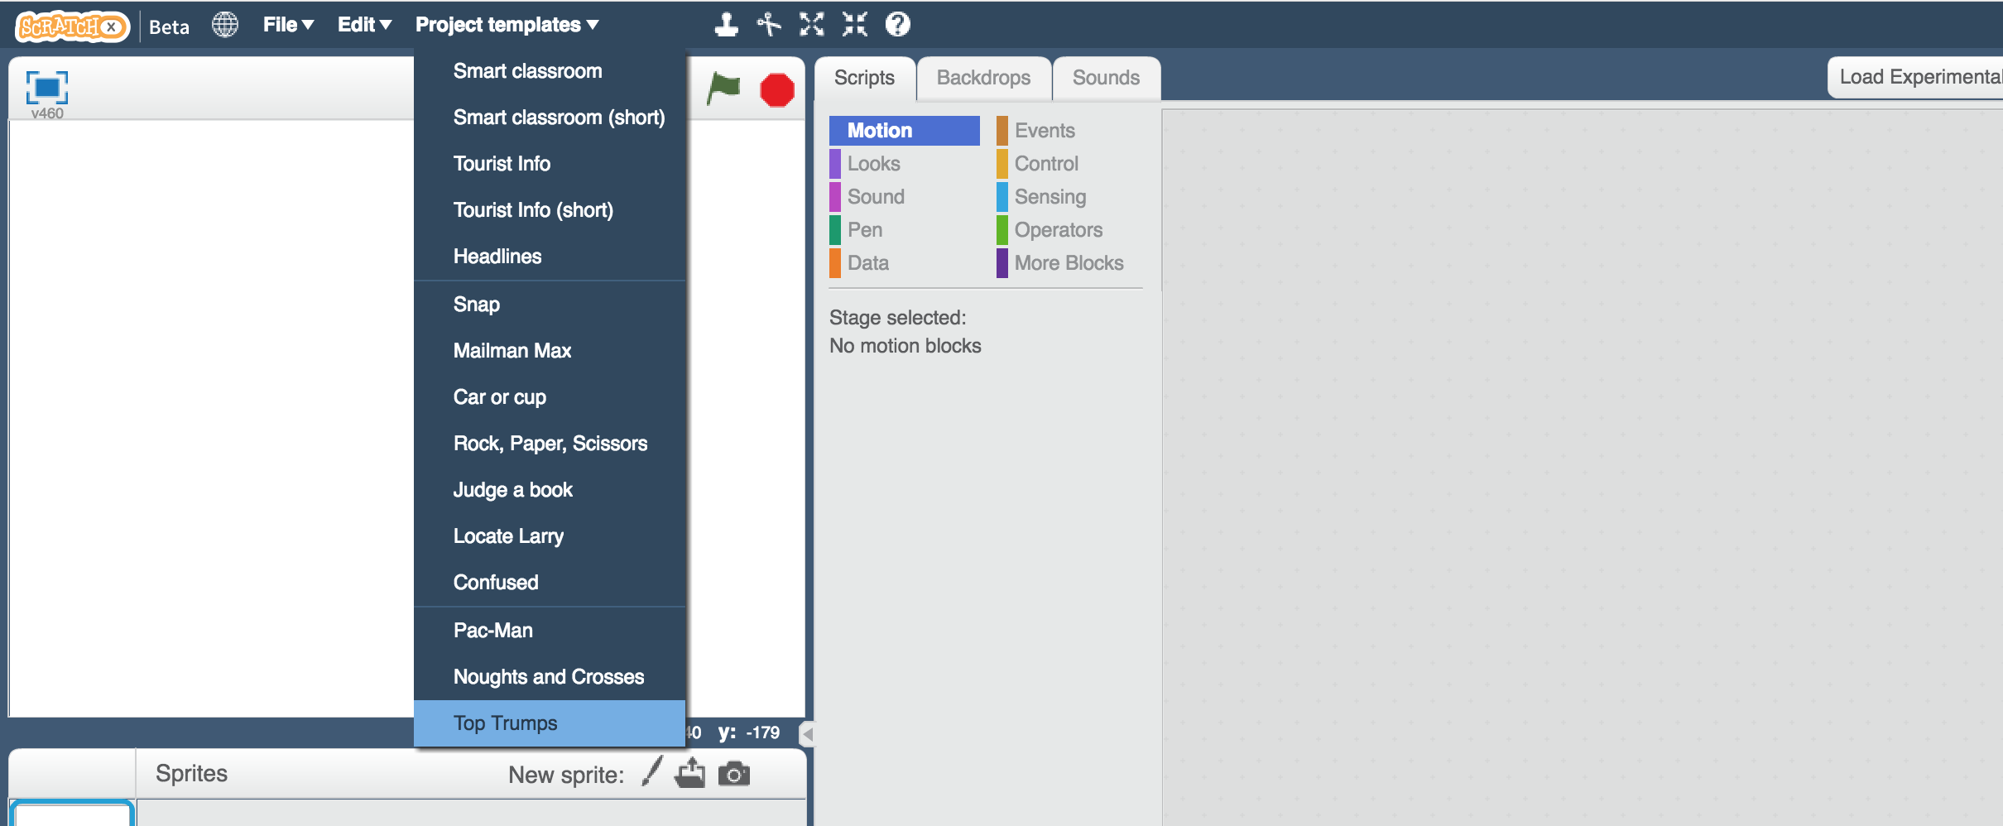*

1. 這就是專案開啟的畫面，點擊全螢幕

This is Top Trumps based on the Kings and Queens of England.   
Click the **full-screen button**.   
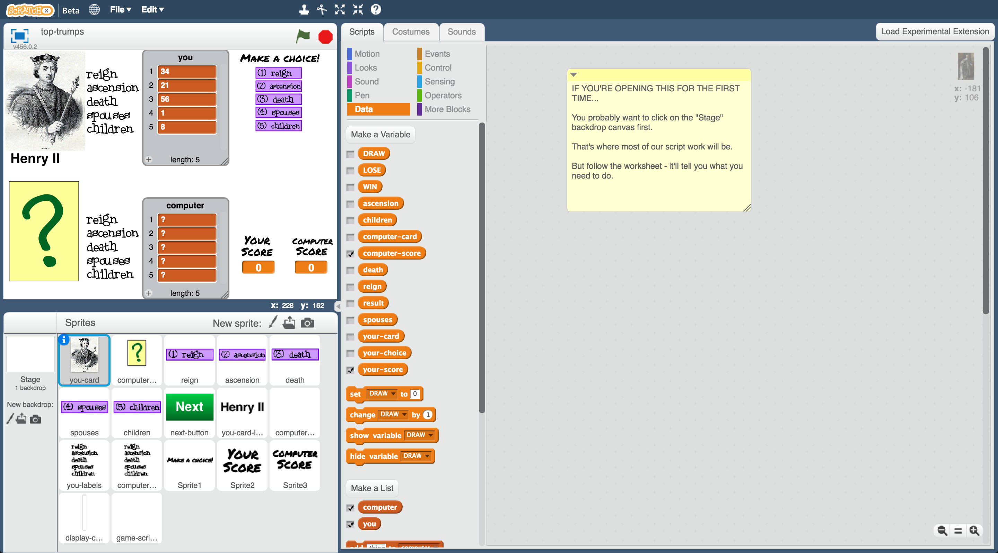

1. 點擊綠旗，開始遊戲

螢幕上半部是你，下半部則是電腦

當你點擊綠旗時，你還看不到電腦的牌，每個欄位都是問號。

決定好要的欄位後點選**欄位旁邊的紫色按鈕**，

按下按鈕後，電腦的卡牌才會出現，勝負也會出現，

右下方的計分板會即時更新。

點擊綠色Next按鈕開啟下一局。如果你贏了或平手，則下一局還是你選擇，**如果你這局輸了，下局會改由電腦選要比的欄位**。

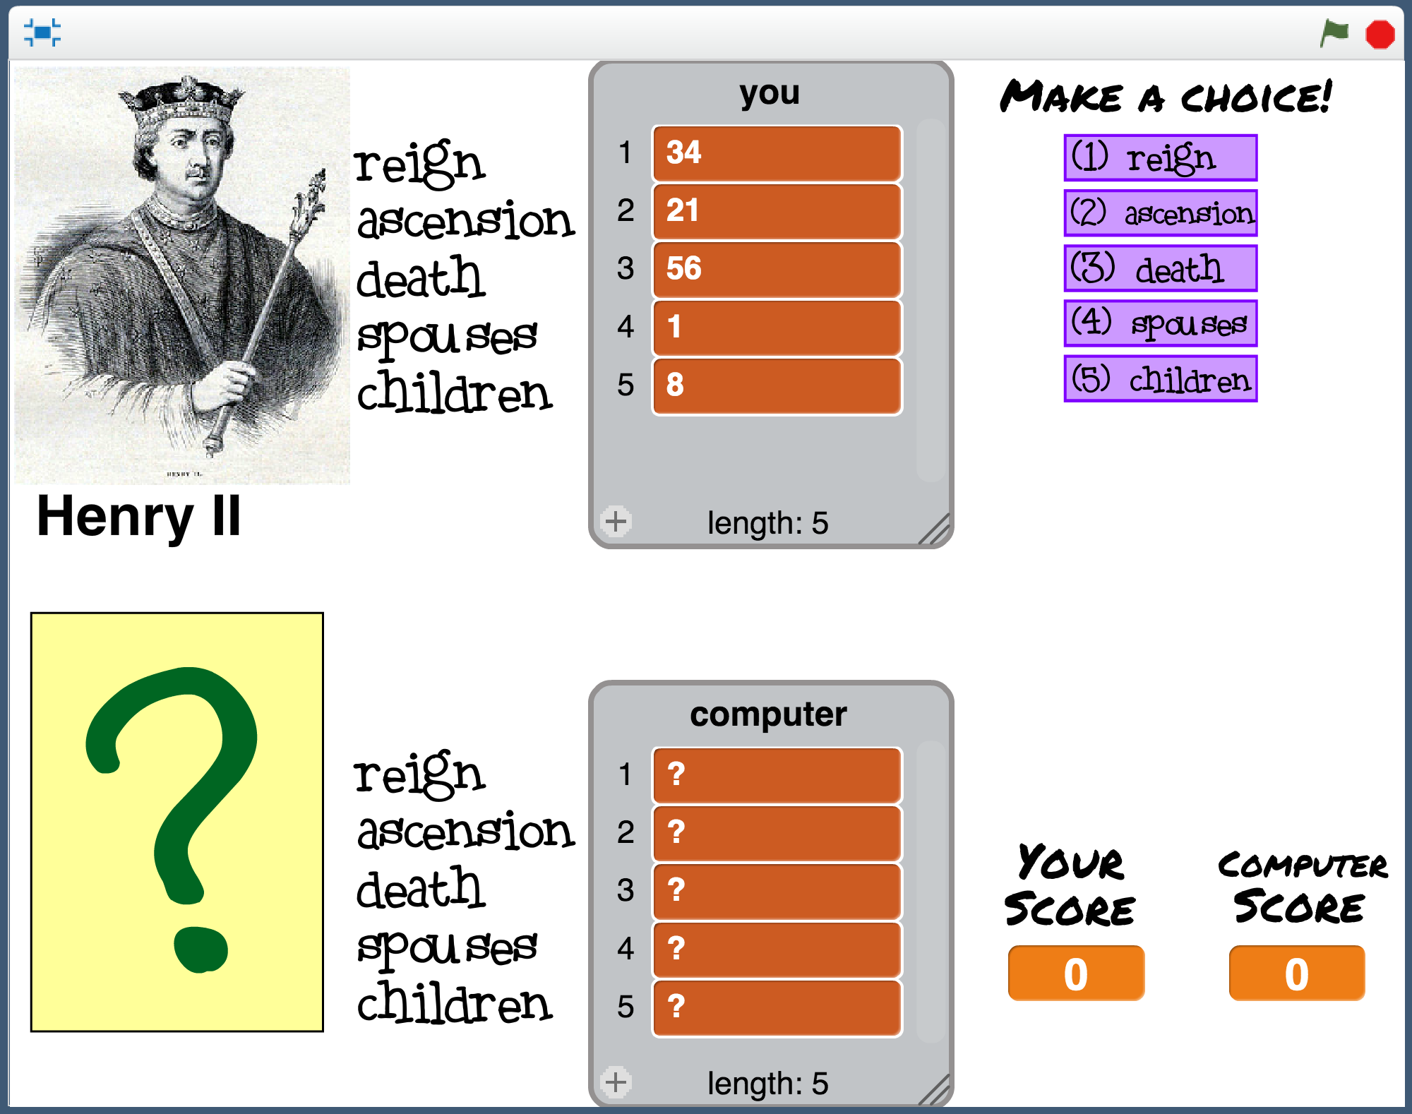 Click the **green flag** to start   
The top half of the screen is you.   
  
The bottom half is the computer.  
   
When you click the Green Flag to start, you can’t see the computer’s card yet.   
  
It’s all just question marks.   
  
Choose a value from your king or queen by **clicking the purple button next to it**  
  
When you choose, the computer card is revealed, and you see if you won or lost.   
  
The score in the bottom right corner is updated.   
  
Click on the green Next button to move onto the next card and play again.  
If you win or tie, it’s your turn again.   
**If you lose, the computer will get to choose the next value instead.**

1. 多玩幾輪

*試著找出電腦是如何選擇要比較的欄位的，當你發現原因後跳至下一步驟*

Play a few rounds of the game against the computer.  
*Try to work out how the computer is choosing values to play.   
When you think you’ve worked out how the computer is playing, move onto the next step.*

1. 回到正常大小的頁面，點選『舞台』

Click on the **full-screen** button again to go back to normal view.   
Then click on the **Stage**   
*This is the white rectangle above “Stage” shown with the arrow below.*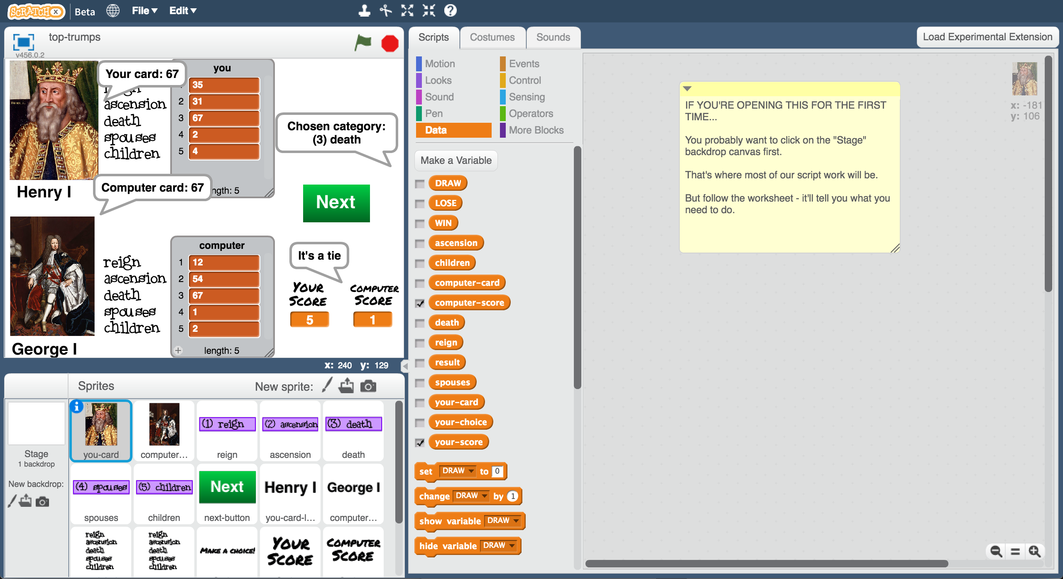

1. 舞台的積木告訴我們電腦是怎麼挑的，**電腦永遠都選擇”reign”**，你答對了嗎？

The script on the **Stage** shows how the computer has been coded.  
**The computer always picks “reign”.**   
*Did you get it right?*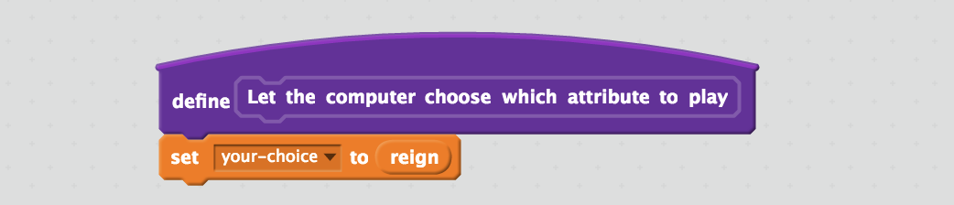

1. 更新程式積木，讓電腦在每次輪到他的時候變成隨機選一個選項來比

*從1(reign)到5(children)之間隨機挑選*

Change the script so that the computer chooses a value at random when it’s the computer’s turn.   
*Choosing from 1 (reign) to 5 (children) at random.*   
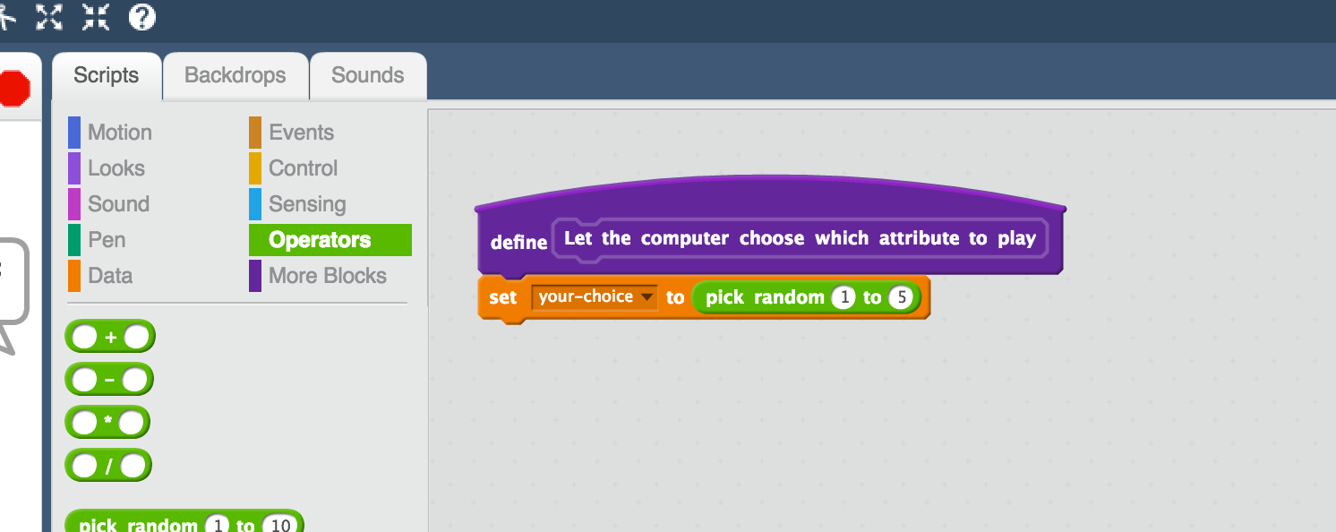

1. 點擊綠旗，重置分數。重新再跟電腦比一次

*當某一方獲得10分時結束遊戲，你贏了嗎。還是電腦贏了？*

Click the **green flag** to reset the scores to 0. Go back to full-screen and play the game again.   
*Stop when either you or the computer reaches 10 points. Who won?*

**到目前為止，你完成些什麼？**

**What have you done so far?**

你設計了一個會玩Top Trumps的機器，並給了他一個很簡單的策略：隨機選擇要比較的項目

You’ve set up a bot to play Top Trumps and given it a simple strategy: choose values at random.

但是人類不會這樣玩，我們會學著去選擇那些讓我們獲勝機率最大的選項，而下某個決定背後的因素來自我們之前看過的牌，以及我們對規則的了解  
But people don’t play like that. We learn how to choose which value would give us the best chance of winning. We do this based on the cards we’ve seen before, and on our understanding of the rules.

接下來，你要更新Scratch程式碼，讓他可以紀錄你的遊戲過程當作訓練範例資料。

Next, you’ll create a Scratch script that collects training examples using the moves that you make.

1. 點選『舞台』，拖曳“**add training data**”積木至程式區

Still on the **Stage**, drag the “**add training data**” block to the canvas  


1. 拖曳程式積木（如下圖）

Add the values from your card to the block  
    

1. 拖曳程式積木（如下圖）

Surround the “add training data” with an “**if**” block like this:  
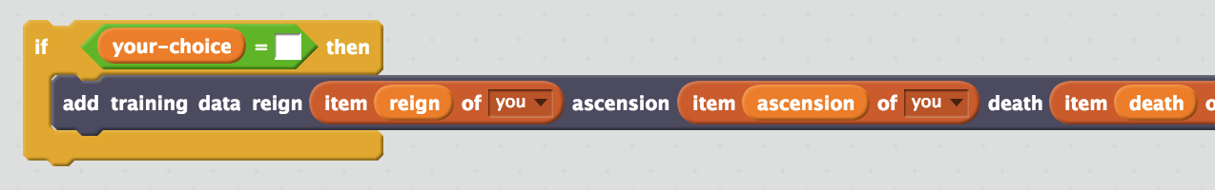

1. 複製五次

*在if上按右鍵，選擇『複製』*

Duplicate it five times – once for each possible choice of value  
*Right-click on the “if” and then choose “Duplicate”*

1. 依序在積木空格裡加上選項（如下圖）

*if條件要放入的選項是用Data區域的橘色積木*

*add training data使用的則是更多積木區域的積木*

Add the choices to each block  
*“if” choices should use orange options from “Data”  
“add training data” choices should use dark options from “More blocks”  
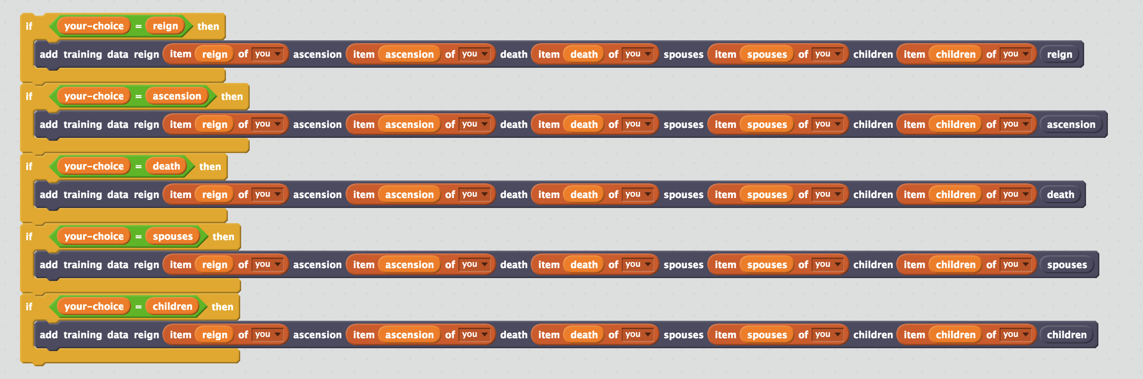*

1. 完成程式組合（如下圖），當你每輪獲勝時都會執行這些積木一次

*當你每次獲勝時，你卡片上的資訊，以及你做的選擇都會被加進訓練資料庫裡*

Finish the script so that this is called every time you win a hand  
*The values that were on your card, and the choice you made, will be added to the training examples every time you win.*  
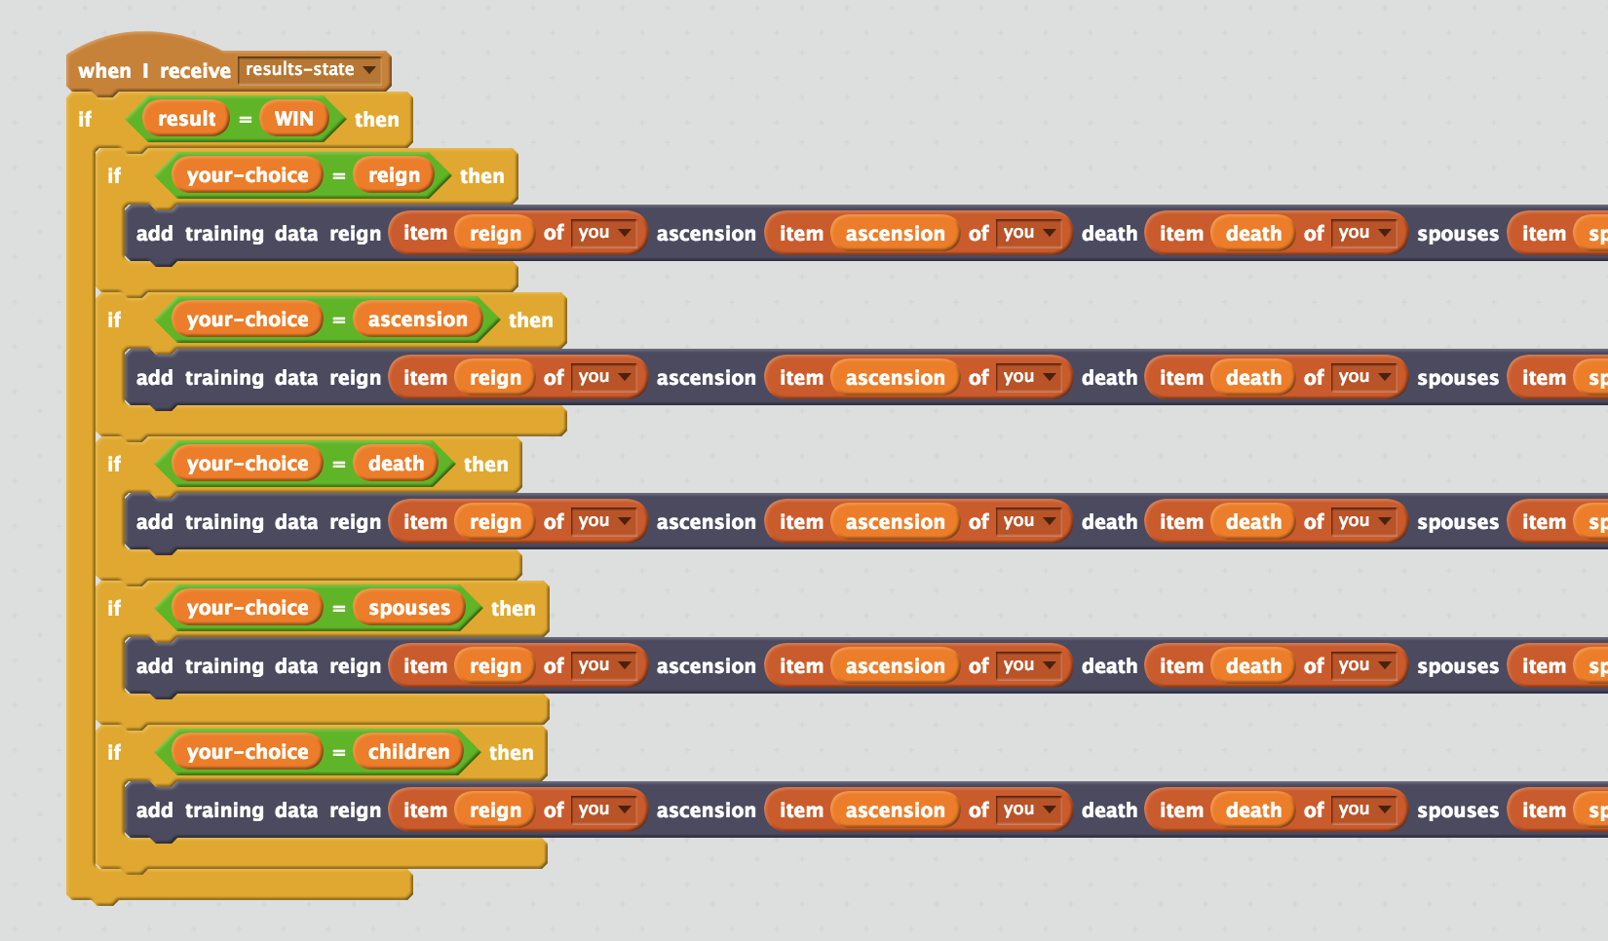

1. 點擊綠旗，重新遊戲，直到你獲得10分為止

Click the full-screen button and green flag again.   
Play games until your score reaches **10**.

1. 存檔

*點選檔案，再點選另存專案*

Save your project  
*Click “****File****” -> “****Save Project****”*  
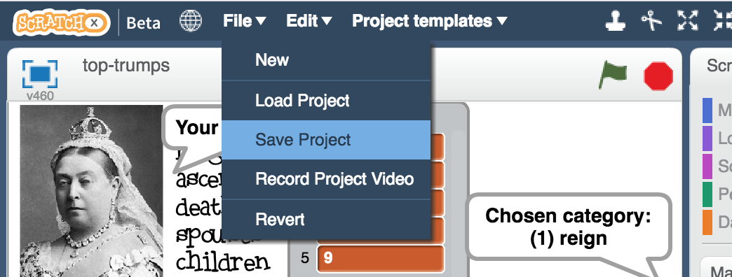

1. 保留Scratch頁面，回到訓練視窗，點選“**< Back to project**”

Leave the Scratch window open.   
In the training window, click the “**< Back to project**” link.

1. 點選“**Train**”

Click the “**Train**” button

1. 檢查訓練資料

*你獲勝的10次遊戲資料應該都已被加入訓練資料庫裡，包含卡牌上的數字以及你當時做的決定*

Check your training data  
*The ten winning moves that you made should have been added to your training examples.  
Each example contains the numbers that were on your card. The bucket that the example is in is the winning choice that you made.*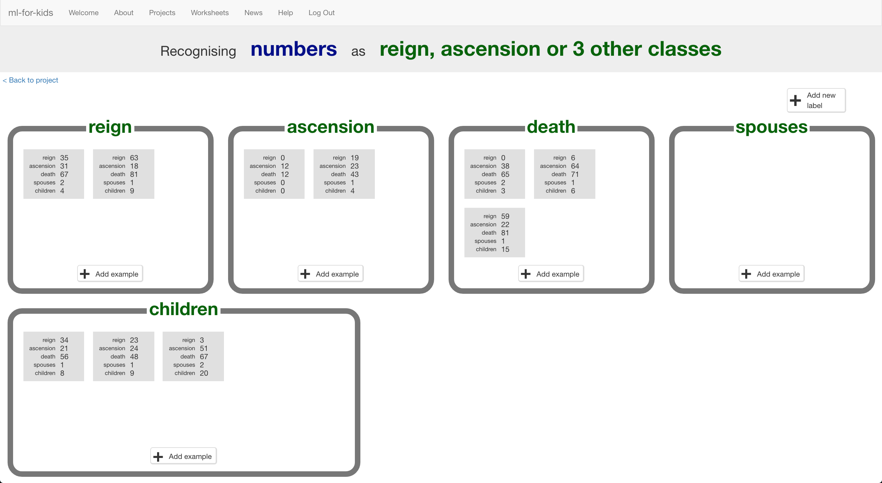

1. 點選“**< Back to project**”按鈕，點選**Learn & Test**

Click the “**< Back to project**” link. Then click “**Learn & Test**”

1. 訓練頁面還不准你開始訓練模型，因為只有10個範例，不夠用來訓練模型

The training page won’t let you train a model yet   
*The ten examples aren’t enough yet to train a model.*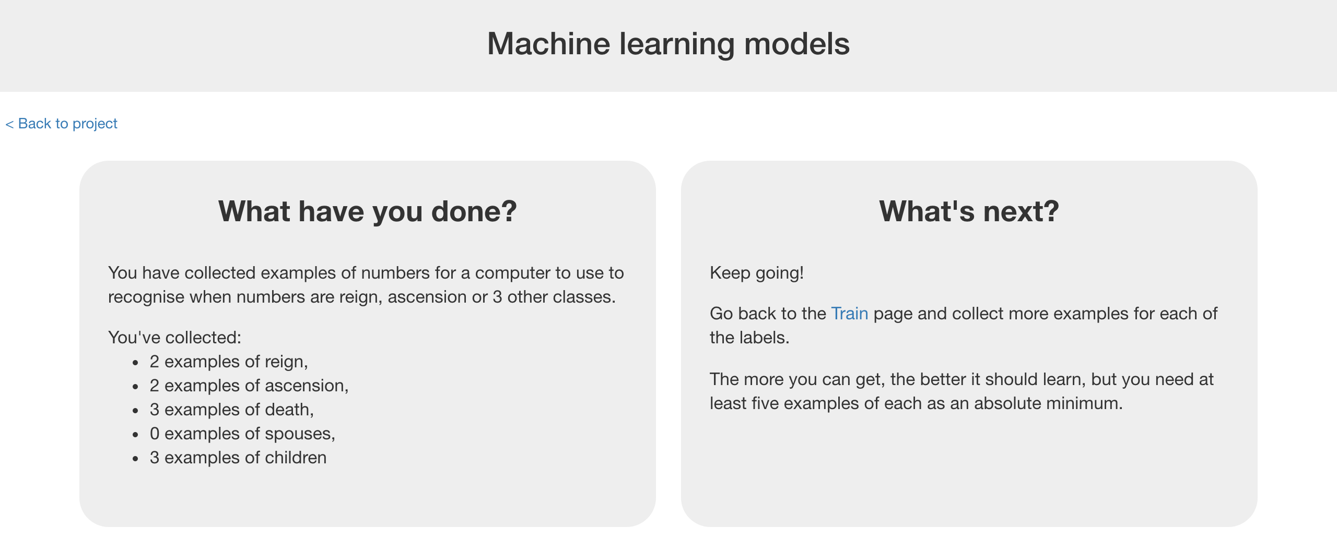

1. 保留頁面，回到Scratch繼續遊戲

Leave the page open.   
Go back to your game in Scratch, and play more games.

1. 多玩幾場後，回到訓練視窗，重整視窗，如果範例數量足夠了，會出現一個“**Train new machine learning model**”按鈕

After a while, go back to the “Machine learning models” page, and refresh the page.   
Keep doing this until you’ve got enough examples for the “**Train new machine learning model**” button to appear.   
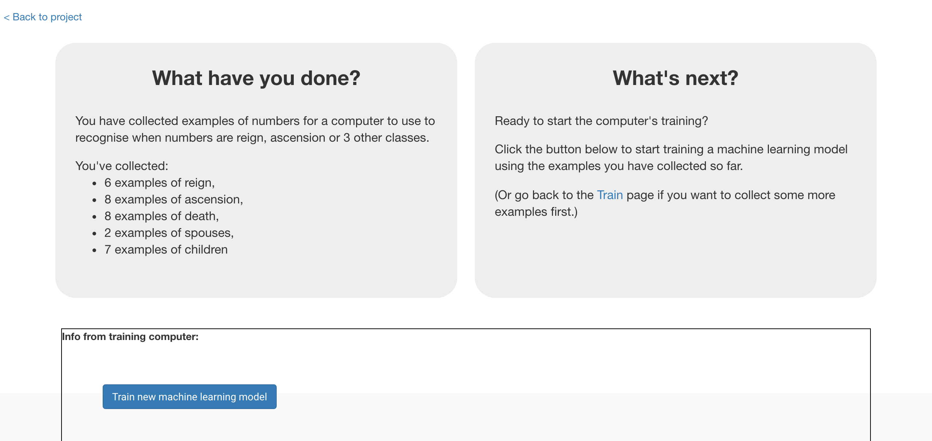

1. 關閉Scratch

Close the Scratch window.

**到目前為止，你完成些什麼？**

**What have you done so far?**

你開始訓練電腦玩Top Trumps卡牌遊戲  
You’ve started to train a computer to learn about Top Trumps.

這些範例幫助電腦學習預測卡牌上的資訊：每個欄位的數值大小範圍是多少、抽到高數字和低數字的期望值是多少等，這些範例同時也幫助電腦在不知道遊戲規則的情況下，學習拿到什麼數字贏的機率最大

The examples help the computer learn what values to expect in cards: the range of numbers for each value, how often it should expect to see high values, how often it should expect to see low values.

The examples also help the computer to learn what numbers are likely to help it to win, without you needing to tell it what the rules are.

1. 點選“**< Back to project**”按鈕，然後點選“**Scratch**”

*綠色點點代表這次有機器學習模型*

Click the “**< Back to project**” link. Then click the “**Scratch**” button  
*The green icon tells you that you have a machine learning model this time.*  
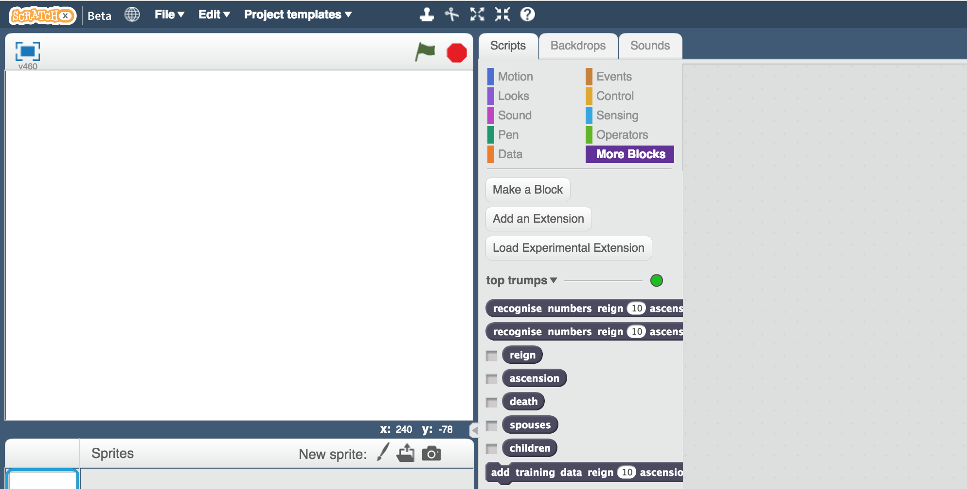

1. 開啟先前儲存的專案

*點選****檔案*** *->* ***開啟專案***

Open the Scratch project you saved before  
*Click “****File****” -> “****Load Project****”*

1. 點選『舞台』

Click on the “**Stage**” to get to where you added the script before

1. 加入“recognise numbers … (label)”程式積木

Add the “recognise numbers … (label)” block  


1. 在空格的地方加入程式積木（如下圖）

Add the values from the computer’s card to the block  
  

1. 加入程式積木（如下圖）

Add it to an “if” block to get a script snippet that looks like this:  
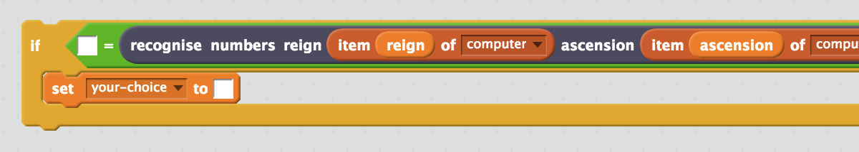

1. 複製5次，新增一個積木：“**Let the computer choose which attribute to play**”，並把所有積木組合起來（如下圖）

*用這個取代先前隨機選擇比較項目的程式積木*

Duplicate the snippet 5 times, and use it to make a new script for “**Let the computer choose which attribute to play**”  
*This replaces the random choice script that was there before*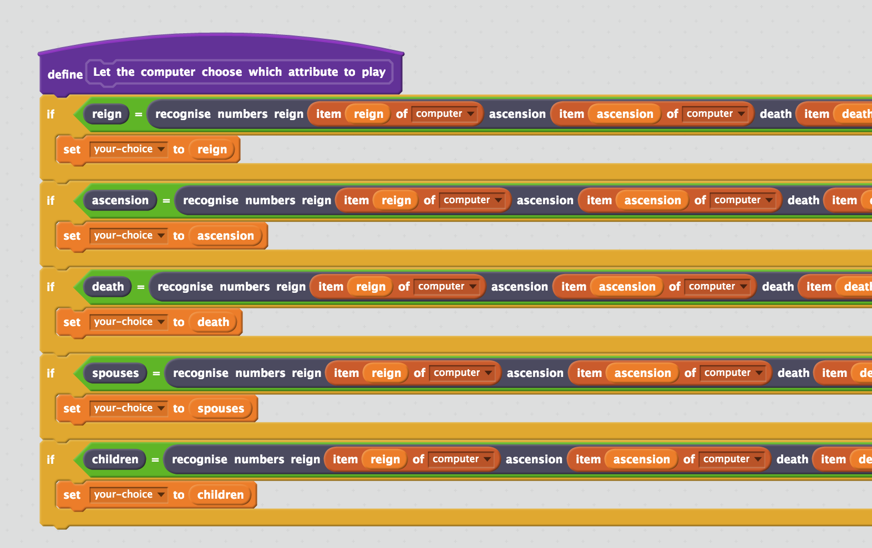

1. 存檔

*點選檔案，再點選儲存專案*

Save your project  
*Click “****File****” -> “****Save Project****”*

1. 繼續玩遊戲，直到你贏得20分

Play the game until you reach the score of **20**

**到目前為止，你完成些什麼？**

**What have you done so far?**

你更新了Scratch的Top Trumps專案，使用機器學習取代先前的隨機選取方式。

You’ve modified your Scratch Top Trumps bot to use machine learning instead of your earlier random approach.

但你蒐集的範例數量還不夠訓練模型，電腦的預測還是會常常出錯。

You haven’t collected nearly enough examples to train a good model yet. The computer won’t have seen enough examples of the game being played to have learned the types of values to expect, or the values that are more likely to win. Its predictions will often be wrong.

為了讓預測效果更好，我們需要更多範例，超多範例！  
To get better, it needs more examples. Lots more examples.

1. 回到訓練視窗

Go back to the training tool window

1. 點選“**< Back to project**”按鈕，再點選“**Learn & Test**”

Click the **“< Back to project**” link, then back to “**Learn & Test**”

1. 點選“**Train new machine learning model**”

Click the “**Train new machine learning model**” button   
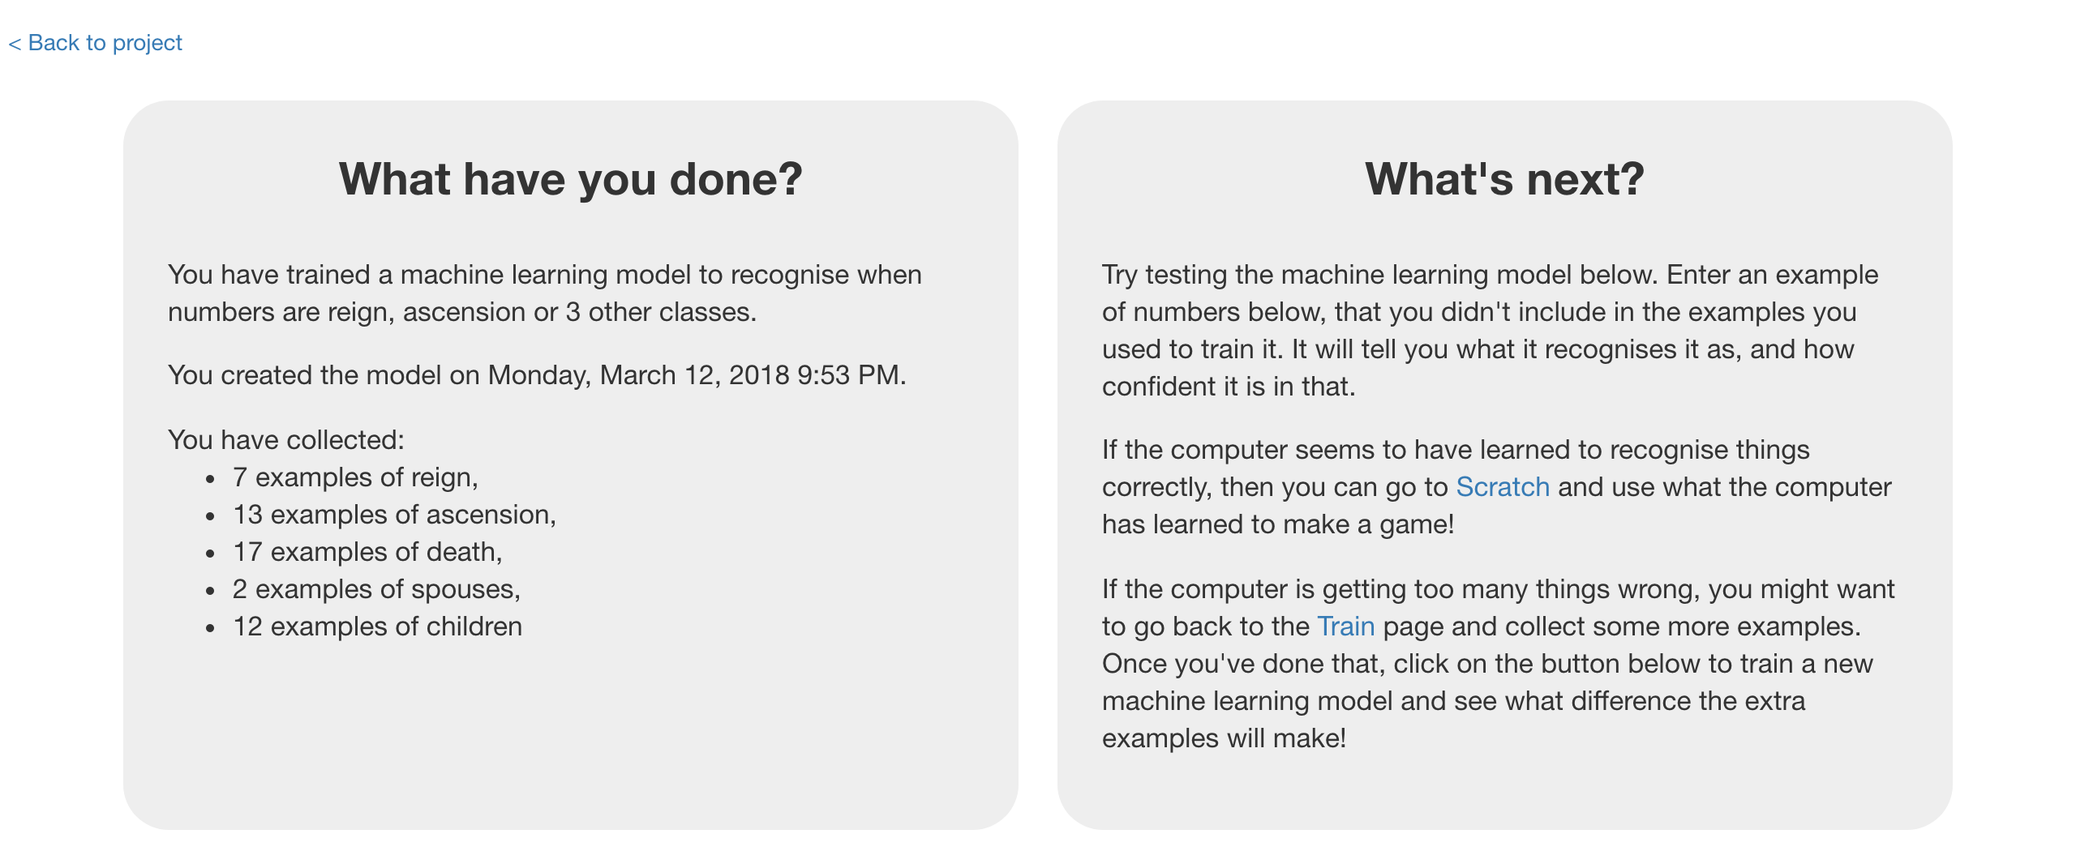

1. 回到Scratch頁面

*如果你剛不小心關掉了，沒關係*

*點選* ***< Back to project*** *->* ***Make*** *->* ***Scratch*** *->* ***Open in Scratch****->****File*** *->* ***Load Project***

Switch back to the Scratch window.   
*If you accidentally closed it, you can get back to it by doing this:  
* Click the “****< Back to project****” link  
* Click the “****Scratch****” button  
* Click the “****Open in Scratch****” button  
* Open the Scratch project you saved before, with “****File****” -> “****Load Project****”*

1. 再玩一次遊戲

*結果如何？電腦現在有沒有比較常贏？*

Play the game again.   
*Is it getting any better? Does the computer win more often now?*

1. 重複步驟48~52，蒐集更多範例，再用這些範例來訓練一個新的機器學習模型。這些動作多做幾次

Repeat steps 48 – 52 to collect more examples, and then train a new machine learning model with them. Do this a few times.

**到目前為止，你完成些什麼？**

**What have you done so far?**

電腦目前只從你做過的決定中學習，為了加快蒐集範例的速度，接下來我們要讓電腦也從他自己的動作中學習

The computer is only learning from the decisions that you make. To speed up the collection of training examples, next you’ll let the computer learn from it’s own moves as well.

1. 開啟Scratch

Open the game in Scratch

1. 找到『舞台』裡以“When I receive ‘results-state’”開頭的積木

Find the “When I receive ‘results-state’” script in the Stage   
that you made earlier

1. 複製“if result = WIN”程式積木

Duplicate the “if result = WIN” block

1. 更新程式積木（如下圖），讓電腦在獲勝時也會把自己所下的動作加到訓練資料庫中

*將”WIN”改成”LOSE” （你輸了就代表電腦贏了）*

*將”you”改成”computer”（這樣才能蒐集電腦卡牌的資訊）*

Modify it so that the computer’s moves can be added to the training examples when the computer scores a point.   
*Change “WIN” to “LOSE” (you lose when the computer scores a point)  
Change the “you” to “computer” (to get values from the computer card)  
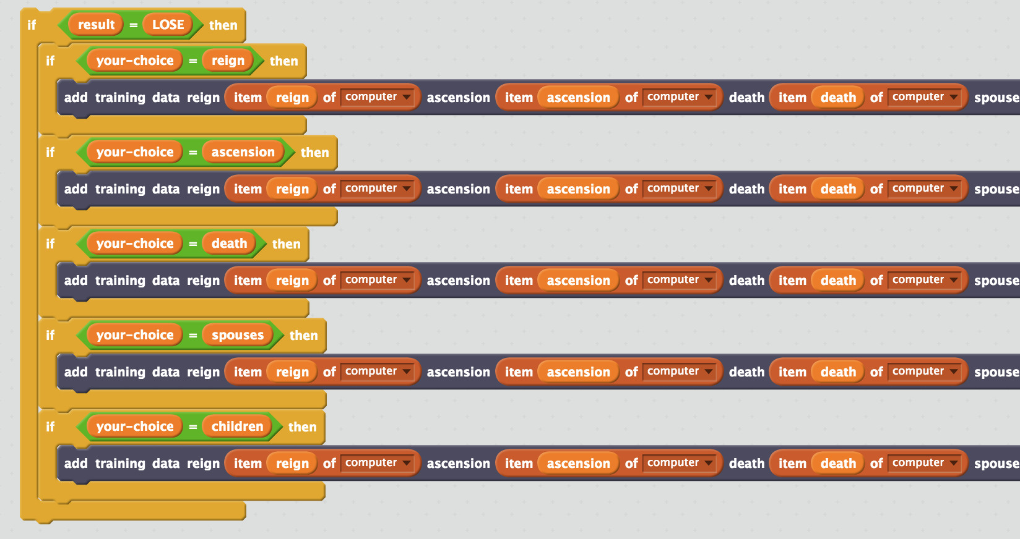*

1. 合併所有程式積木（如下圖）

Join it all up  
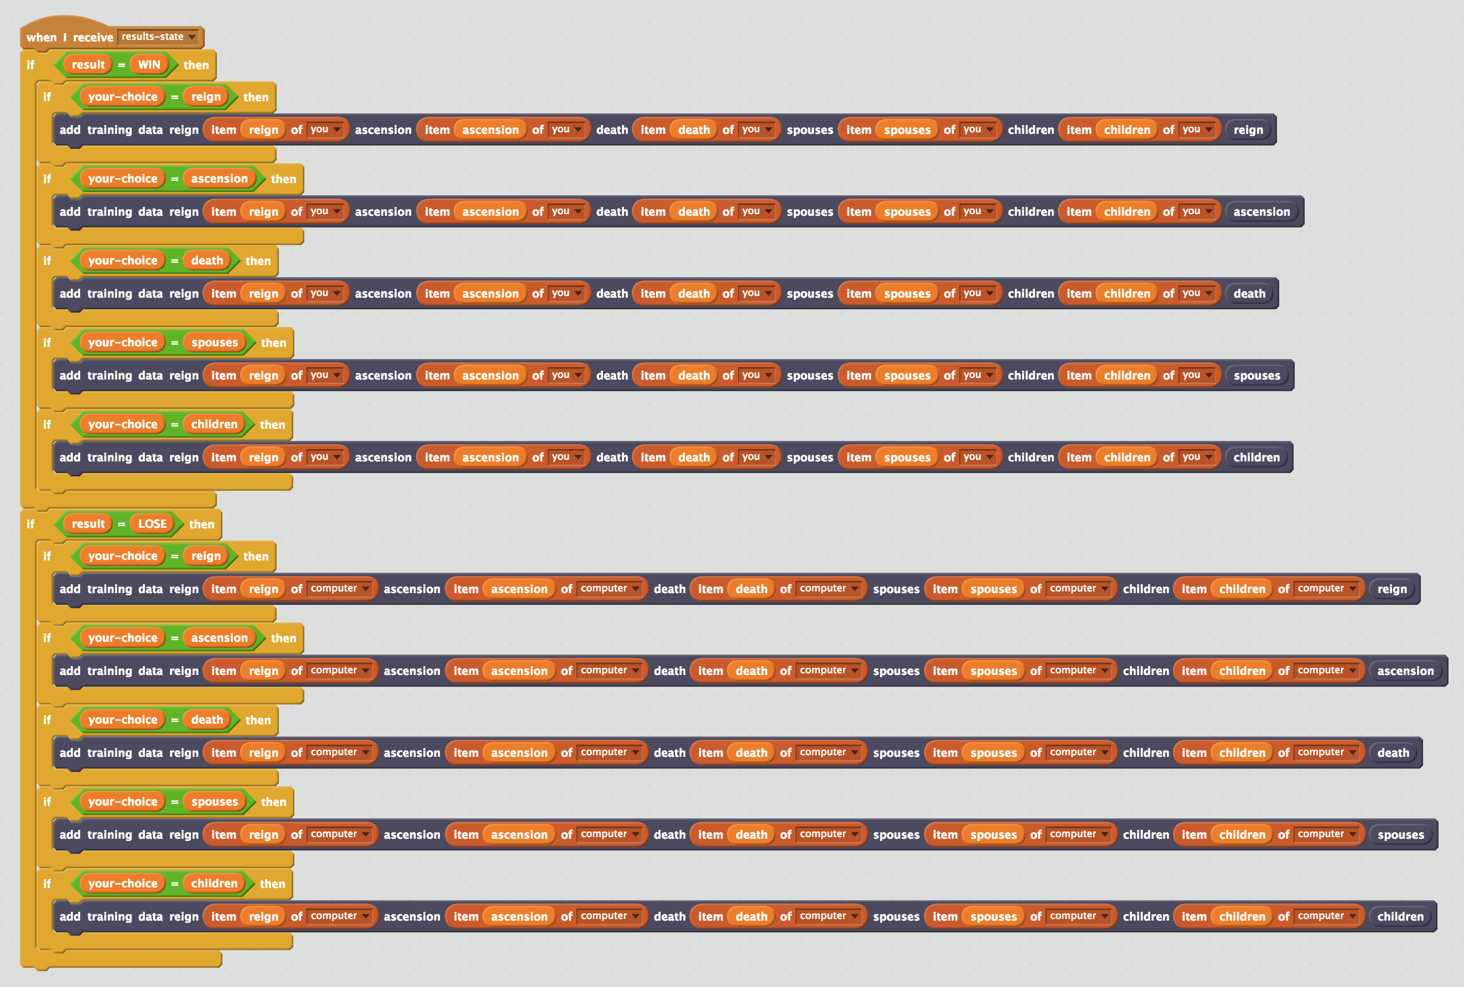

**你完成了什麼？**

**What have you done?**

你設計了一個從遊戲過程學習的Top Trumps機器人。這代表你不用先等電腦學習規則就可以直接開始跟電腦玩這個遊戲（雖然電腦一開始會輸很慘）。透過玩遊戲，電腦會從這些經驗中學習，並且玩得越來越好。

You’ve made a Top Trumps bot that can learn by playing the game. This means you don’t need to wait for the computer to have learned before it can start playing. It can start playing (even if it loses a lot at first), straight away. And by playing the game, it will learn from those experiences how to get better.

你並沒有告訴電腦該做什麼，只是讓電腦去發現做哪些決定贏的機會更高。

You haven’t told the computer what to do, but allowed it to try out different choices and discover what choices are more likely to help it to win.

這稱之為強化學習(reinforcement learning)，當做出一個好的決定，電腦會透過贏得勝利來強化

This is called “reinforcement learning”. When it makes a good choice, this is reinforced by the computer being told that it has won.

**訓練Top Trumps機器人的一個小範例**

**An example of training a Top Trumps bot**

*注意！你的結果和這個範例會不相同*

*這些是從我的機器人上蒐集到的結果*

*Your results will be different to this.*

*But these were the results I got from training my bot.*

|  |  |  |
| --- | --- | --- |
|  | **分數** | |
| **人類** | **電腦** |
| 無訓練 – 電腦隨機選擇 | 72 | 28 |
| 用100個範例訓練 | 47 | 53 |
| 用200個範例訓練 | 38 | 62 |
| 用300個範例訓練 | 29 | 71 |
| 用400個範例訓練 | 25 | 75 |
| 用500個範例訓練 | 27 | 73 |
| 用600個範例訓練 | 29 | 71 |
| 用700個範例訓練 | 27 | 73 |

|  |  |  |
| --- | --- | --- |
|  | **Score** | |
| **Human** | **Computer** |
| No training – computer choosing at random | 72 | 28 |
| Trained with 100 examples | 47 | 53 |
| Trained with 200 examples | 38 | 62 |
| Trained with 300 examples | 29 | 71 |
| Trained with 400 examples | 25 | 75 |
| Trained with 500 examples | 27 | 73 |
| Trained with 600 examples | 29 | 71 |
| Trained with 700 examples | 27 | 73 |

*總結來說，越多訓練，結果越好。*

*有段期間電腦在訓練後反而表現得更糟，你覺得原因是什麼？*

*過了某個點後，即使我持續加入更多訓練資料，電腦依舊沒有進步，你覺得原因是什麼？*

*將我的這些結果和你的做比較，你的機器人學習狀況如何？*

*In general, more training is better.*

*There were times where the computer did worse after more training.*

*Why do you think that was?*

*After a certain point, the computer’s scores stopped improving, even after I kept adding more and more training.*

*Why do you think that was?*

*Compare these results with the results from your bot. How has your bot learned from the training you’ve given it?*